# Numbering Olympic athletes by medals earned

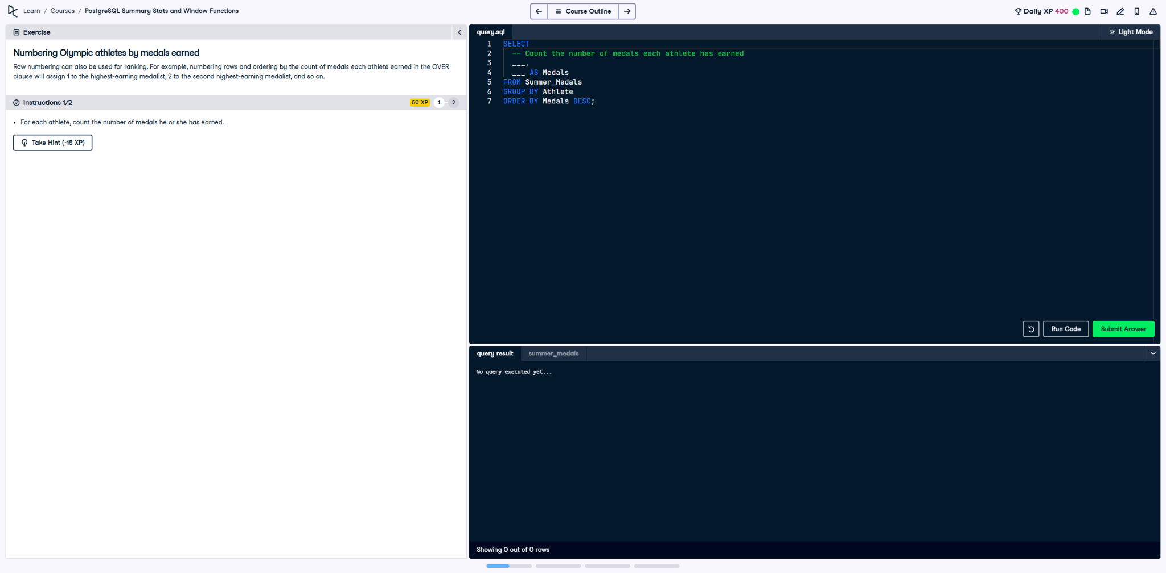

Row numbering can also be used for ranking. For example, numbering rows and ordering by the count of medals each athlete earned in the `OVER` clause will assign 1 to the highest-earning medalist, 2 to the second highest-earning medalist, and so on.

This exercise involves counting the number of medals each athlete has earned and then ranking them in descending order of medals earned.

## Correct Answer

SELECT  
 Athlete,  
 COUNT(*) AS Medals,  
 ROW_NUMBER() OVER (ORDER BY COUNT(*) DESC) AS Rank  
FROM Summer_Medals  
GROUP BY Athlete  
ORDER BY Medals DESC;

Explanation of the query:

1. `SELECT Athlete, COUNT(*) AS Medals`: Selects each athlete and counts the total number of medals they earned, with `COUNT(*)` aggregating all their entries in the dataset.

2. `ROW_NUMBER() OVER (ORDER BY COUNT(*) DESC) AS Rank`: Assigns a rank to each athlete based on the total count of medals in descending order, where the highest medalist receives rank 1.

3. `GROUP BY Athlete`: Groups the data by athlete to compute their total medal count.

4. `ORDER BY Medals DESC`: Sorts the results by the total number of medals in descending order, aligning with the ranking.